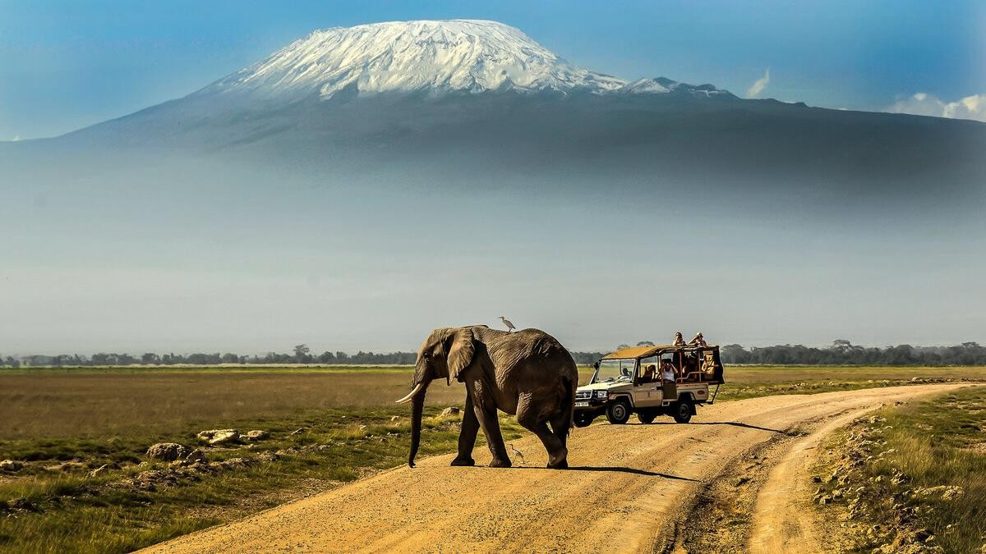
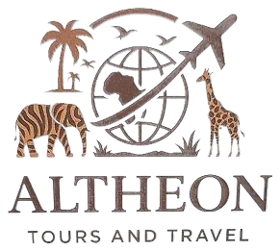


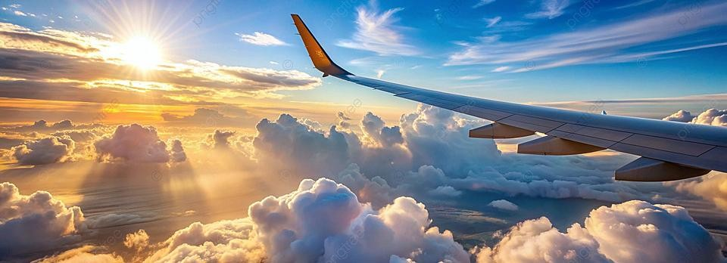
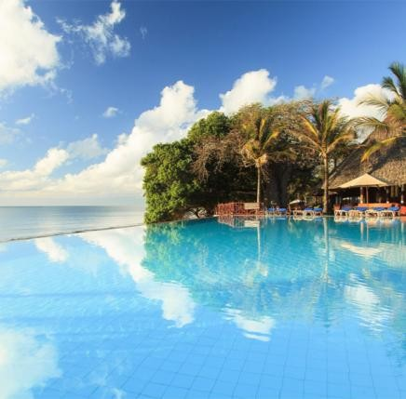
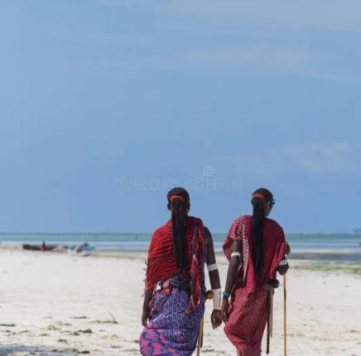
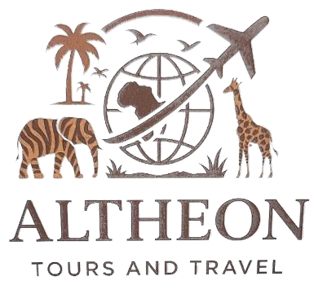
ALTHEON
T O U R S & T R A V E L
Travel, thoughtfully curated.
COMPANY PROFILE
2026
TEMBEA KENYA THE ALTHEON WAY
01
/ WELCOME
Welcome to ALTHEON
Precision, comfort and unforgettable experiences.
We curate journeys for those who value
precision, comfort and unforgettable
experiences.
Every trip is thoughtfully designed, professionally executed and supported from
start to finish
—
ensuring a seamless, elevated travel experience.
“Travel is more than logistics, it's about creating memories that last
a lifetime.”
02

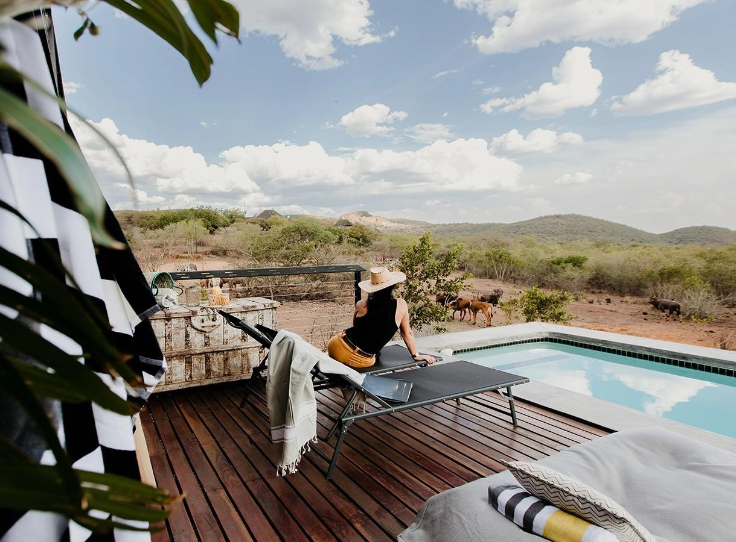


02
/ ABOUT US
About Us
A thoughtful approach to travel, built around the client.
Welcome to Altheon Tours and Travel, where
we curate journeys for those who value
precision, comfort, and unforgettable
experiences.
We plan every detail with care, sophistication and discretion. Each journey is
tailored to your purpose, preferences and lifestyle, executed flawlessly, and
supported from start to finish.
At Altheon, travel is more than logistics
—
it is a seamless,
elevated experience designed to exceed expectations.
Precision • Comfort • Discretion
03




03
/ OUR FOUNDATION
Purpose with a sense of place.
◉
OUR VISION
To become a trusted and distinguished travel
partner in Kenya and beyond, known for creating
seamless, personalized and memorable travel
experiences that inspire people to explore the
world with confidence.
◎
OUR MISSION
To provide exceptional travel and tourism solutions tailored to every client's
purpose, preferences and lifestyle, combining professional expertise,
personalized service, comfort and attention to detail.
OUR CORE VALUES
01
EXCELLENCE
High standards in every journey
and interaction.
02
PERSONALIZED SERVICE
Solutions tailored to individual
needs and preferences.
03
INTEGRITY & TRUST
Honesty, transparency and
professionalism.
04
ATTENTION TO DETAIL
Careful planning that makes travel
seamless.
05
RELIABILITY
Responsive support throughout the
journey.
06
DISCOVERY & EXPERIENCE
Meaningful experiences and
lasting memories.
04


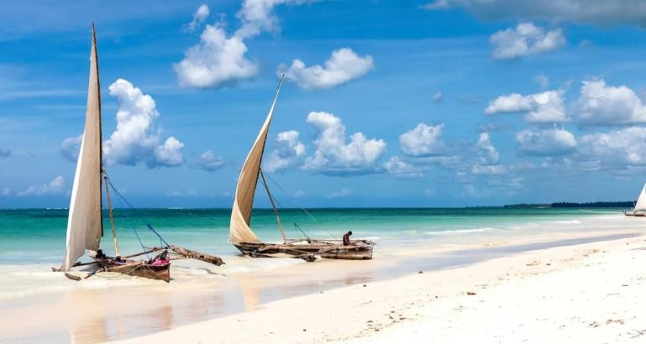
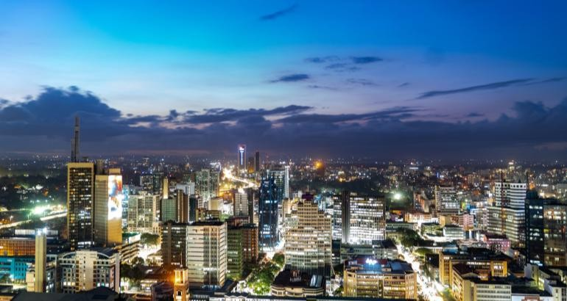
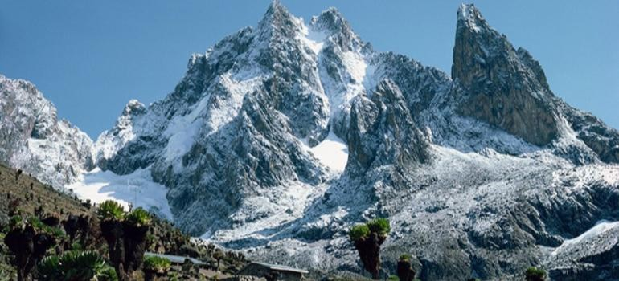
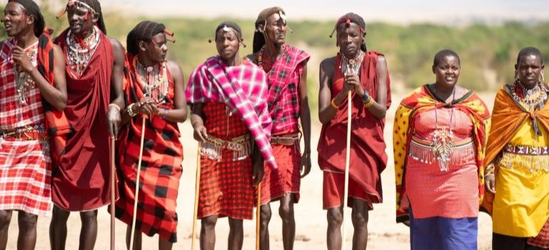
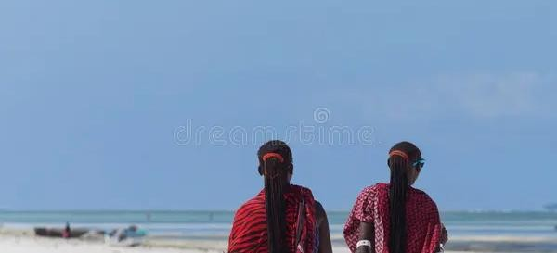

04
/ EXPERIENCES
Tembea Kenya the Altheon Way
From iconic wildlife to coastal escapes, discover Kenya through experiences made for you.
0
1
Maasai Mara & Wildlife
0
2
Kenyan Coast & Beaches
0
3
Nairobi & City Experiences
0
4
Mount Kenya & Nature
0
5
Adventure & Culture
0
5
Adventure & Culture
05











05
/ OUR SERVICES
Everything arranged around your journey.
Professional travel solutions, tailored to your purpose.
✈
Air Ticketing
Domestic & international flight bookings.
⌂
Hotel & Accommodation
Hotels, resorts, lodges and guesthouses.
⚑
Safari & Wildlife
Curated experiences across Kenya's iconic
destinations.
☘
Holiday & Leisure
Beach holidays, honeymoons, family &
weekend escapes.
⊕
International Travel
Planning for Africa & worldwide destinations.
✉
Corporate Travel
Professional solutions for companies &
organizations.
⌥
Group Travel
Coordinated travel for groups, schools &
conferences.
☷
Visa Assistance
Guidance with travel documentation & visa
processes.
⚑
Airport Transfers
Smooth arrival & departure arrangements.
CUSTOMIZED EXPERIENCES • Tailor
-
made itineraries around your interests and schedule.
06
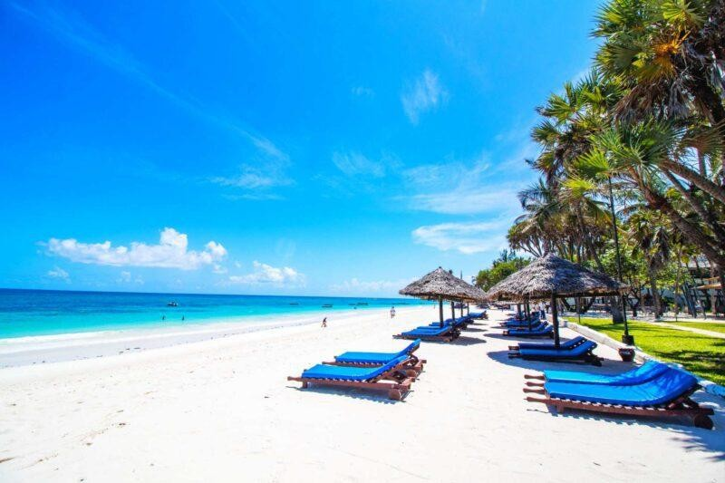







06
/ THE ALTHEON DIFFERENCE
Why Choose Altheon?
A more thoughtful way to travel.
0
1
Personalized
Every journey is designed around your needs, preferences and purpose.
0
2
Attention to Detail
We carefully manage the details that make travel seamless.
0
3
Comfort & Convenience
We prioritize a smooth and comfortable experience from planning to arrival.
0
4
Professional Service
Responsive, polished and attentive service.
0
5
Tailor
-
Made
Travel experiences shaped around your interests and lifestyle.
0
6
Reliable Support
Support throughout the planning and travel process.
Your Journey, Our Priority.
07

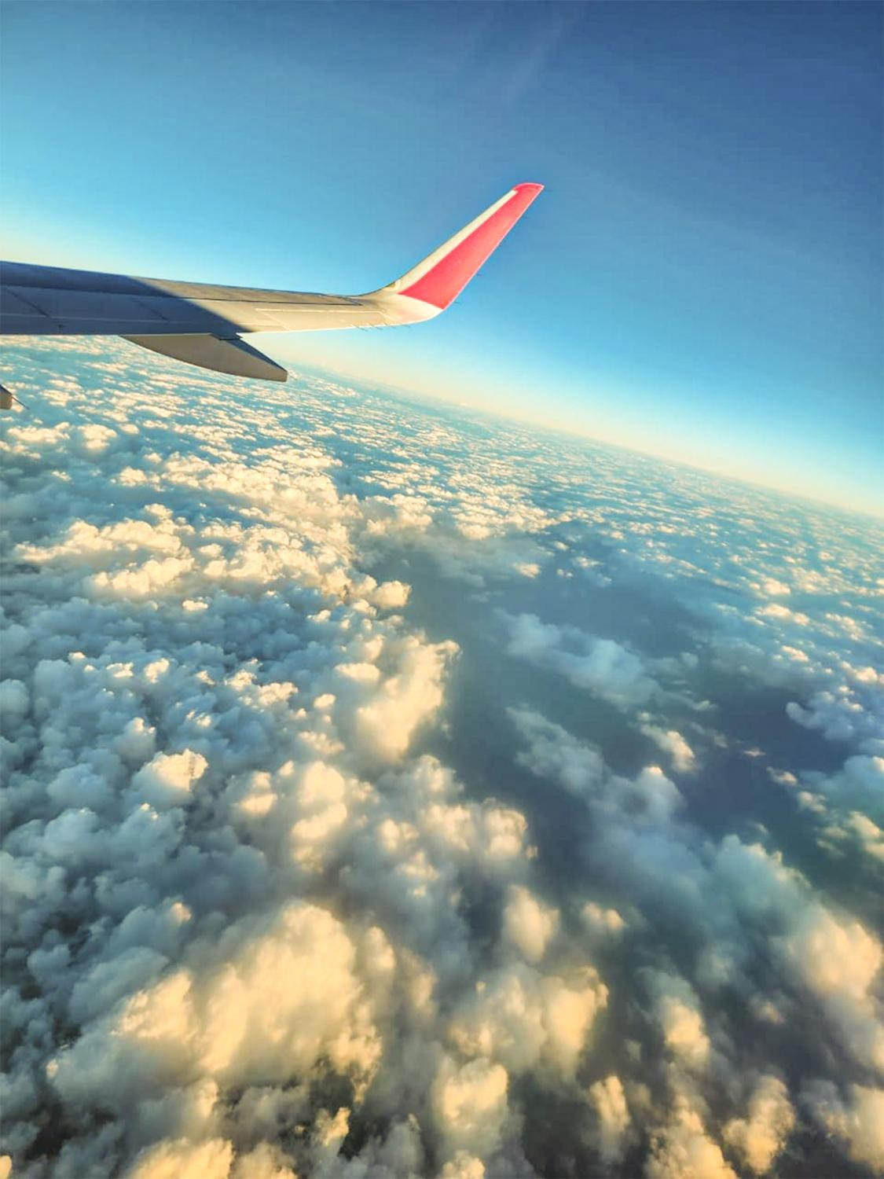

07
/ CORPORATE TRAVEL
Business travel, handled with precision
.
Efficient, reliable and carefully coordinated solutions.
We understand that business travel requires efficiency, reliability and
careful coordination. Our corporate travel solutions help organizations
manage their travel requirements smoothly while allowing their teams to
focus on their core responsibilities.
✈
Corporate Air Ticketing
Domestic & international flights.
⌂ Hotel & Accommodation
Selected based on comfort, convenience &
requirements.
📅
Business Trip Planning
Coordinated arrangements around schedules &
objectives.
👥
Group & Conference Travel
For teams, delegates & events.
📄
Travel Policy Support
Aligned with company policies & budgets.
BUSINESS TRAVEL • GROUPS • CONFERENCES • EXECUTIVE SUPPORT
08
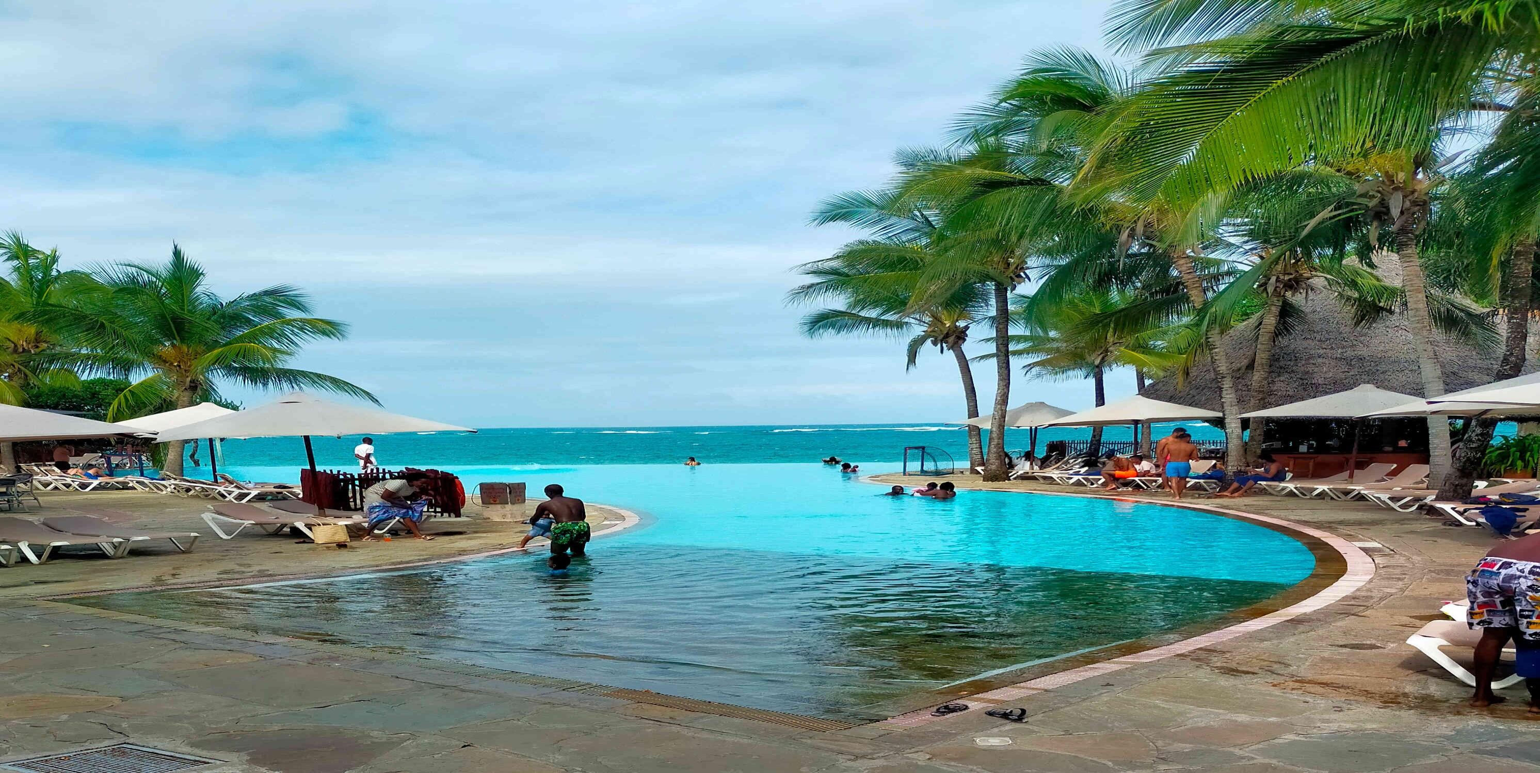


LET'S PLAN YOUR NEXT JOURNEY
Travel • Explore • Experience
ALTHEON TOURS AND TRAVEL
Precision • Comfort • Unforgettable Experiences
PHONE
0718 441 414
EMAIL
altheontours@gmail.com
LOCATION
Nairobi, Kenya
TEMBEA KENYA THE ALTHEON WAY
2026
09

